**Software Engineering**

**Deliverable # 5**

**Group Members:**

Ali Kamal (19I-1865)

Daniyal Shaiq (19I-1794)

Muhammad Zeeshan (19I-1711)

**Review Sprint-Report**

**Introduction of project**

Birgi is a blogging website meant to be used by users of all backgrounds and interests. It provides facilities to its users, by allowing them to make and publish their own blog posts, as well as allowing users to rate and comment on other users’ blog posts as well. Furthermore, to protect the integrity of the website and its contents, administrators are provided with tools to delete users’ blog posts, as well as prevent unfavorable users from making posts in the future.

**Explanation of architecture of project and justification**

Streamlit and HTML is being used for designing the frontend of the blogging website. Streamlit is an easy-to-use web framework in Python. It has in-built features for programming web behavior. Streamlit also handles the backend side of the website. All the backend management is done using Streamlit, and for the data storage SQLite is used. SQLite is an easy-to-use database service available on Python. Streamlit was used in creating this website because it is an easy-to-use framework in Python. Style of functions in Streamlit are very similar to native Python. Moreover, SQLite is available in Python, so it was easier to interact with frontend and database as both packages were in the same language.

**Complete Product backlog**

|  |  |  |
| --- | --- | --- |
| **Sprint-user story** | **Tasks** | **Status** |
| **Sprint 1:**   * User story 1 * User story 2 * User story 3 * User story 4 | * Create an account * Login to account * View articles on website * Recover lost password of account | Incomplete and moved to sprint 3 |
| **Sprint 2:**   * User story 8 * User story 9 * User story 10 * User story 11 * User story 12 | * Users able to make their blog posts on the website * Users able to delete any blog posts they have made * Admins able to delete any article * Admins able to block any user from the website from posting * Admins able to access a user’s data | Completed within planned time |
| **Sprint 3:**   * User story 2 * User story 5 * User story 6 | * Users able to be able to rate and like their favorite articles * Users able to comment on articles * Recover lost password of account | Completed within planned time |

**Complete Product burndown chart**

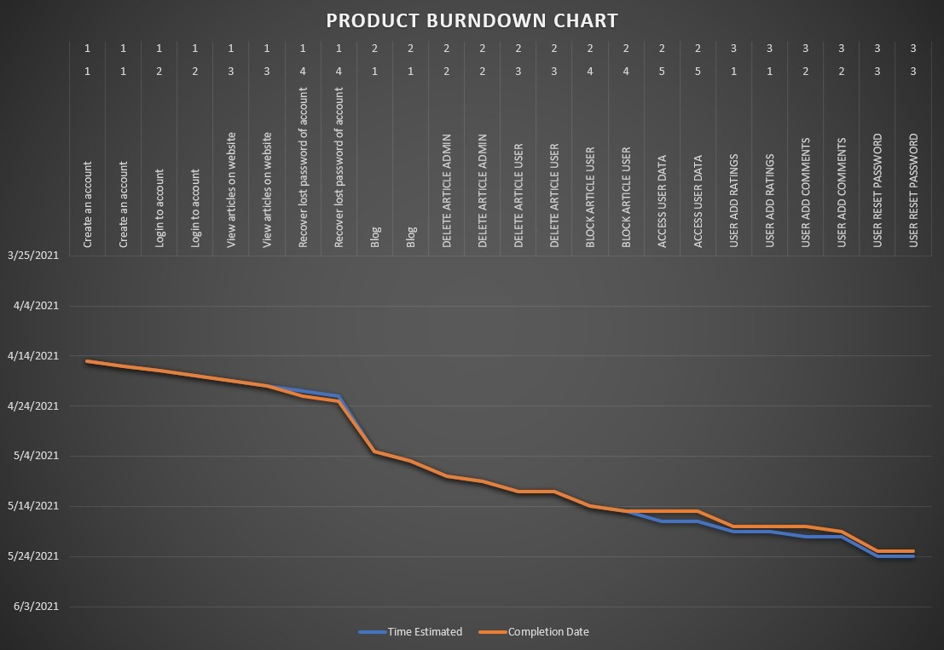

**Trello snapshot of each sprint**

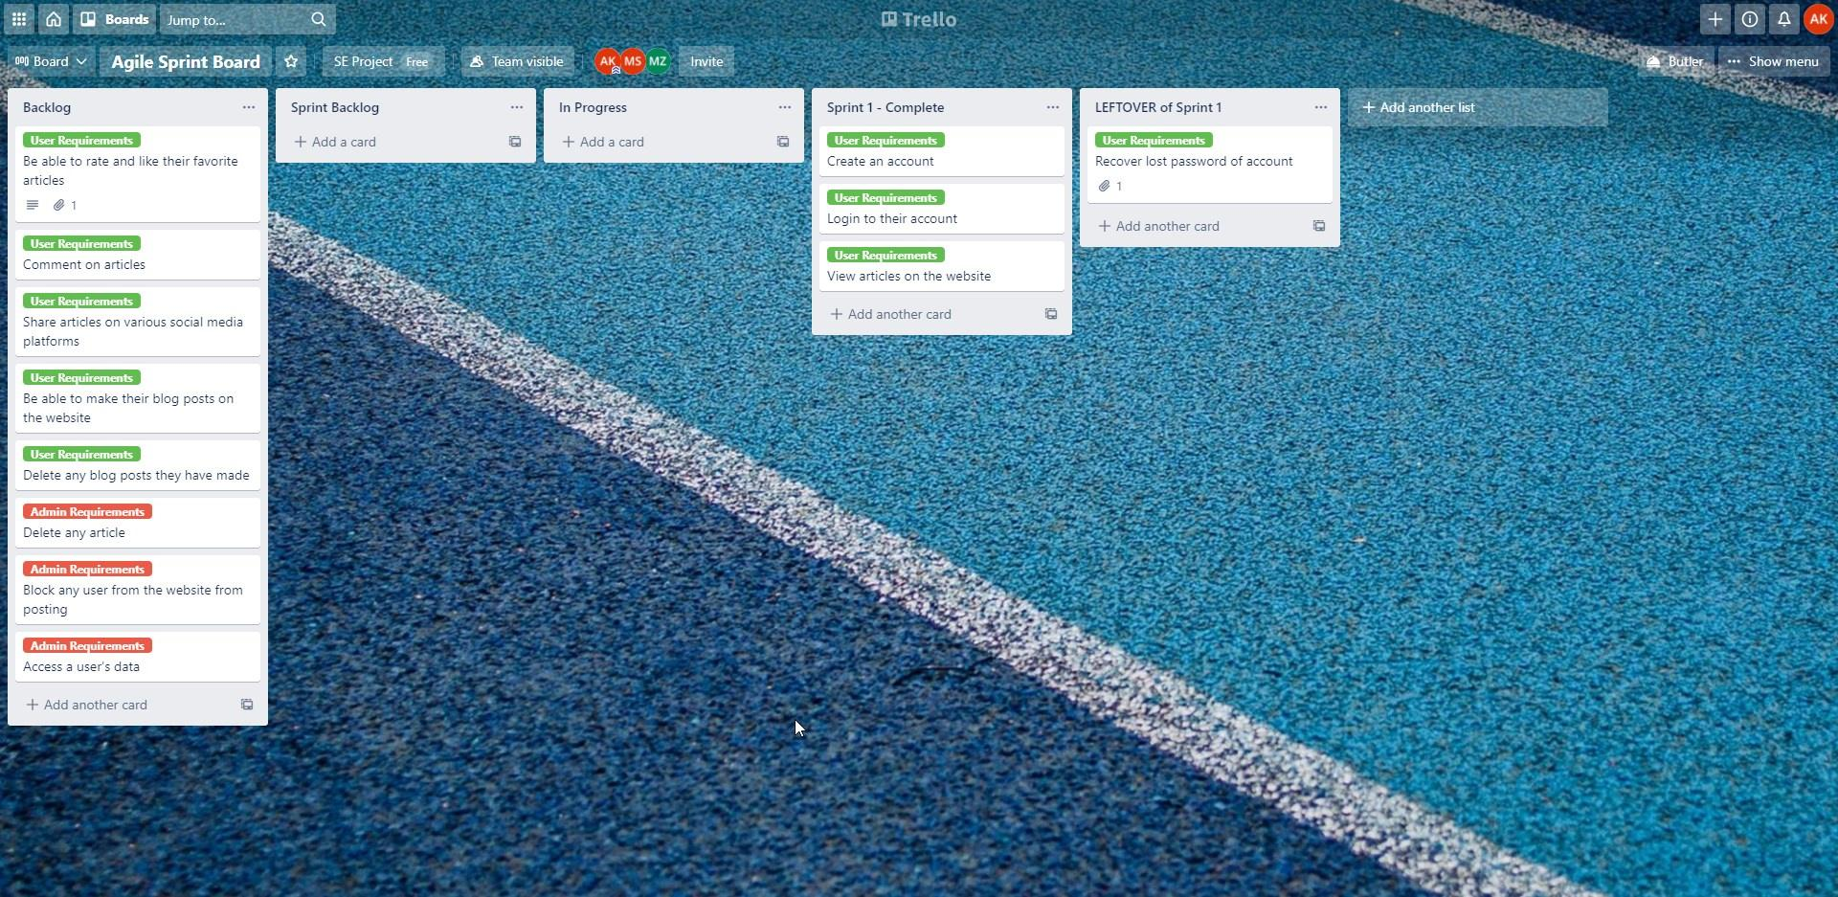**Sprint 1:**

**Sprint 2:**

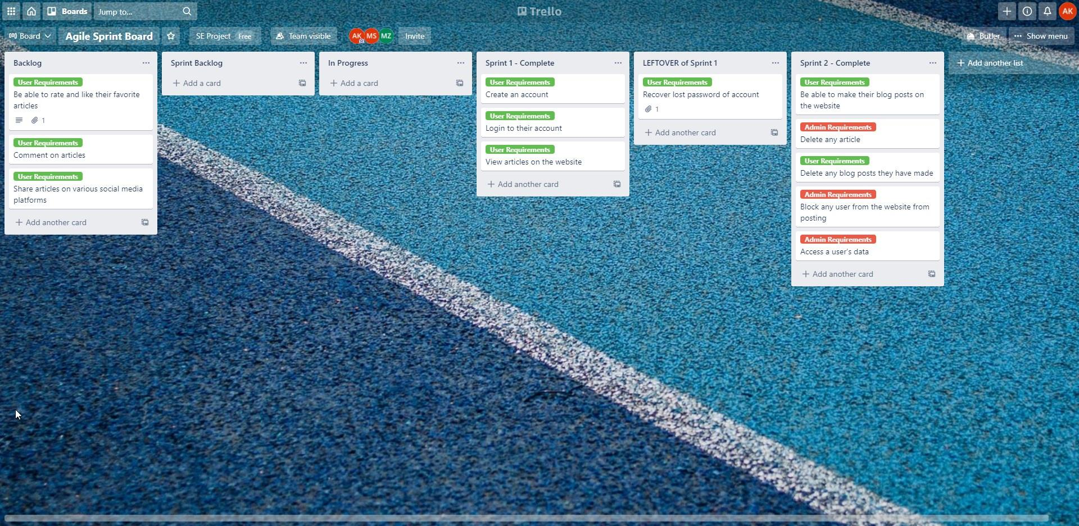

**Sprint 3:**

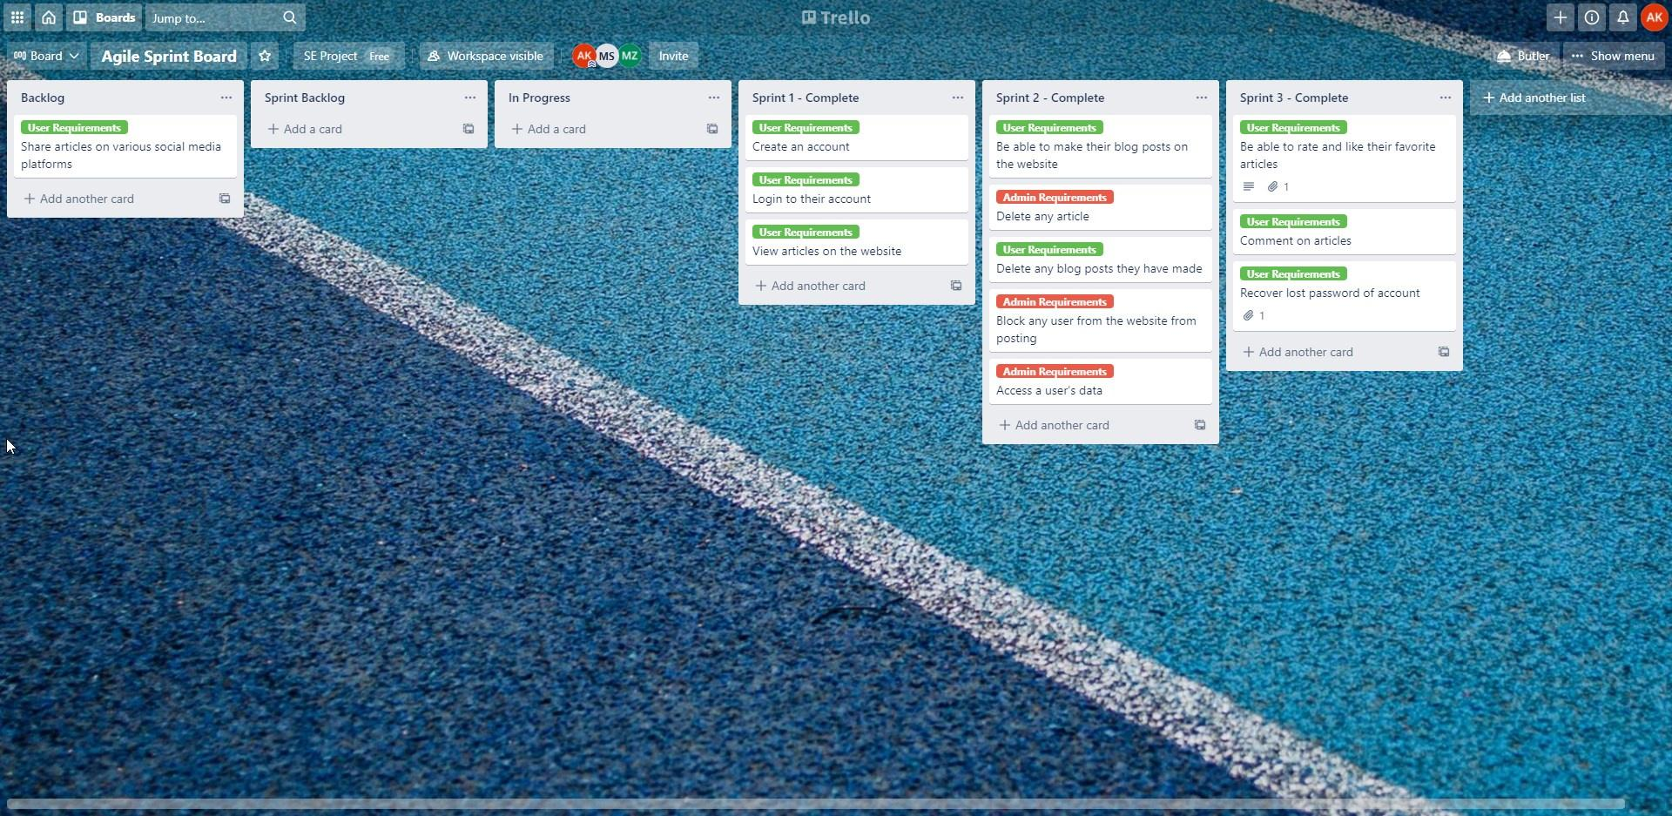

**End of Project at completion:**

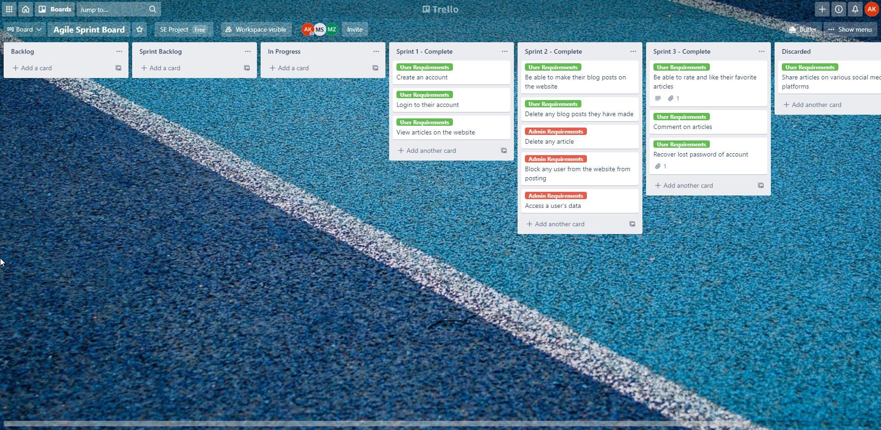

**Complete GUIs of project modules with testing**

1. **User adding a post:**

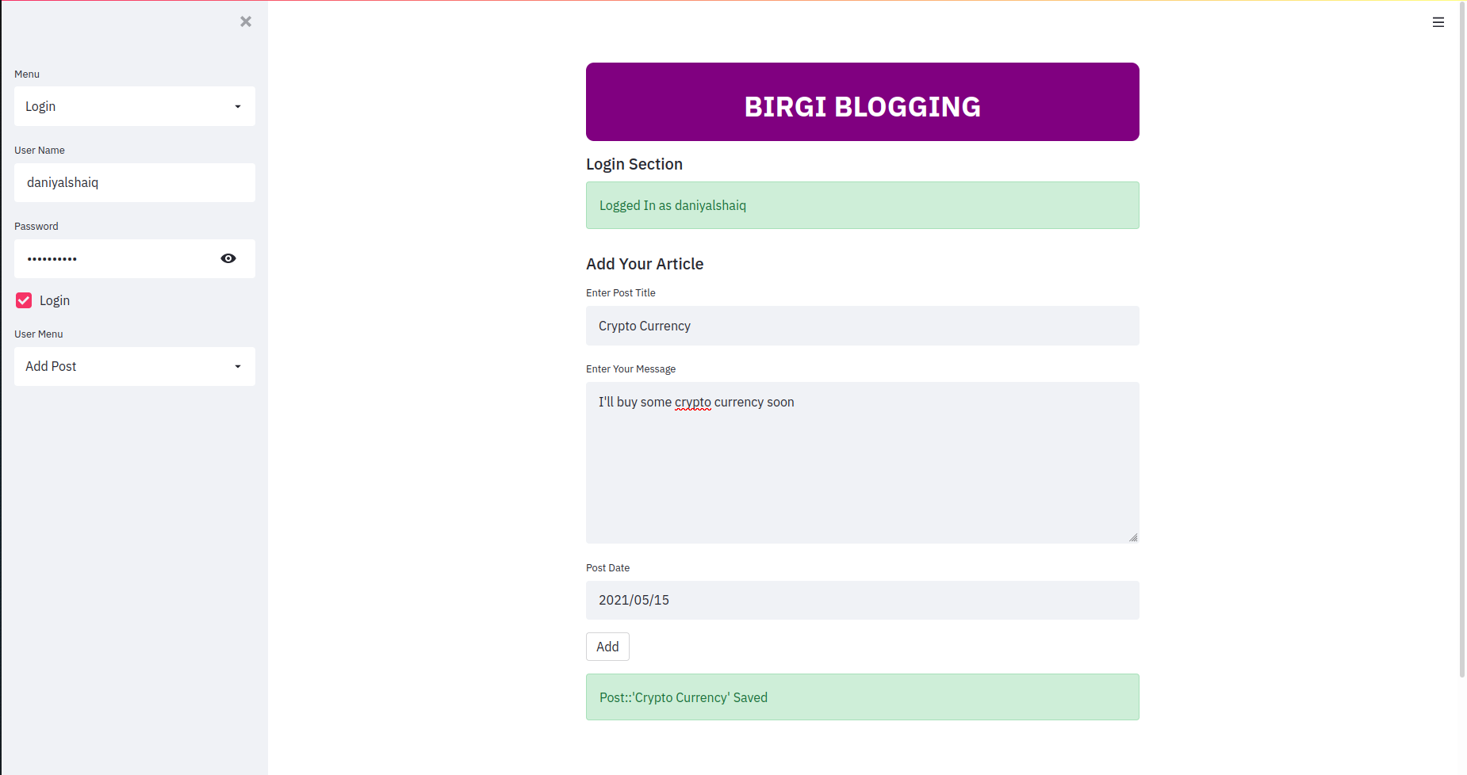

1. **Admin deleting a user’s post:**

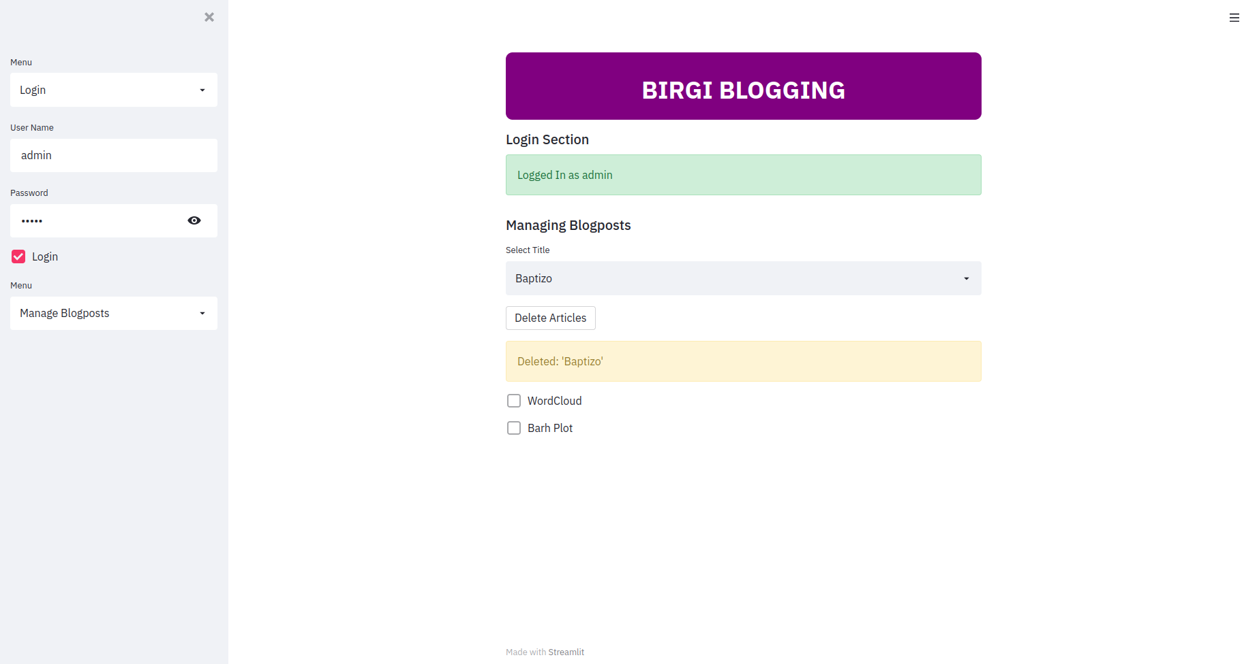

1. **Viewing a user’s data i-e articles posted by them:**

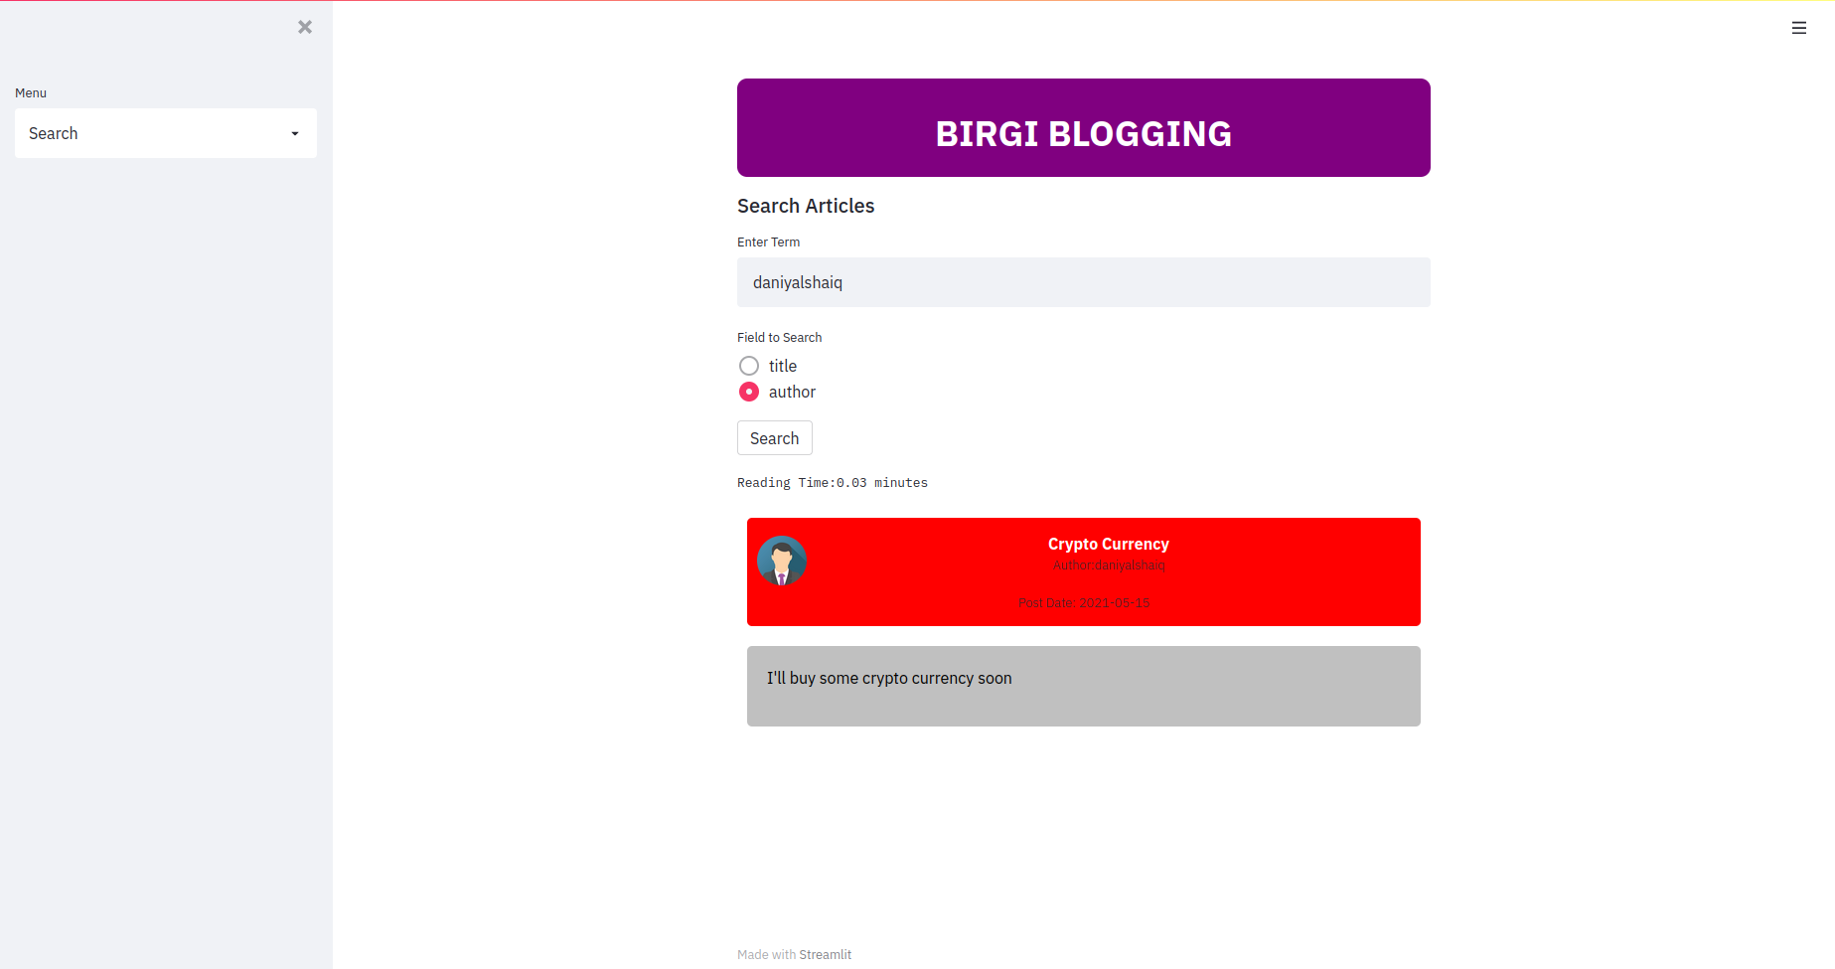

1. 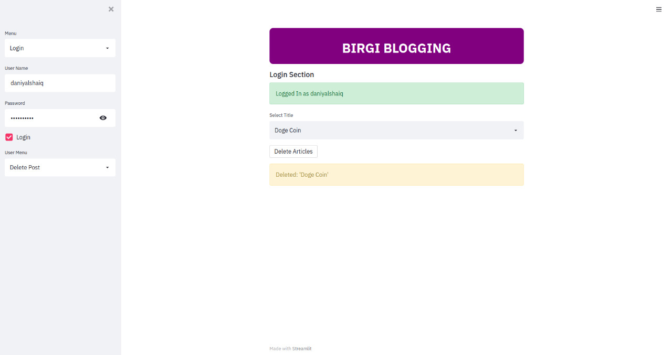**Users deleting their own posts:** 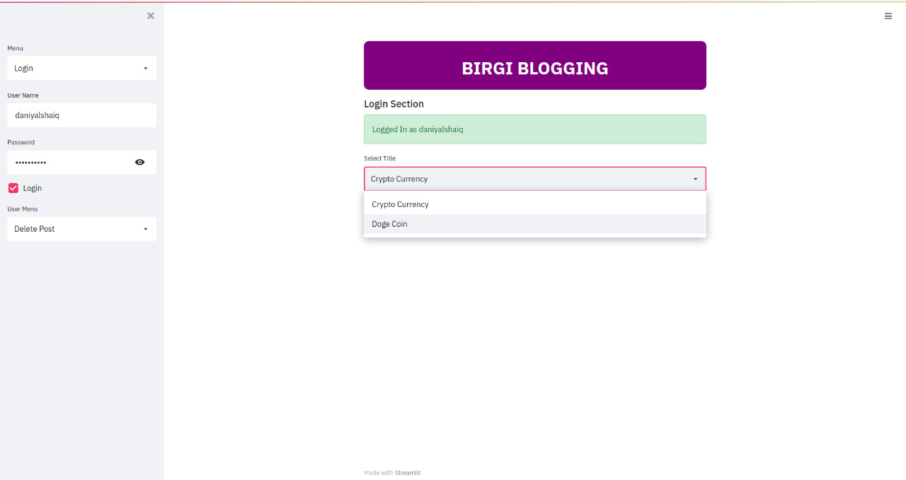
2. 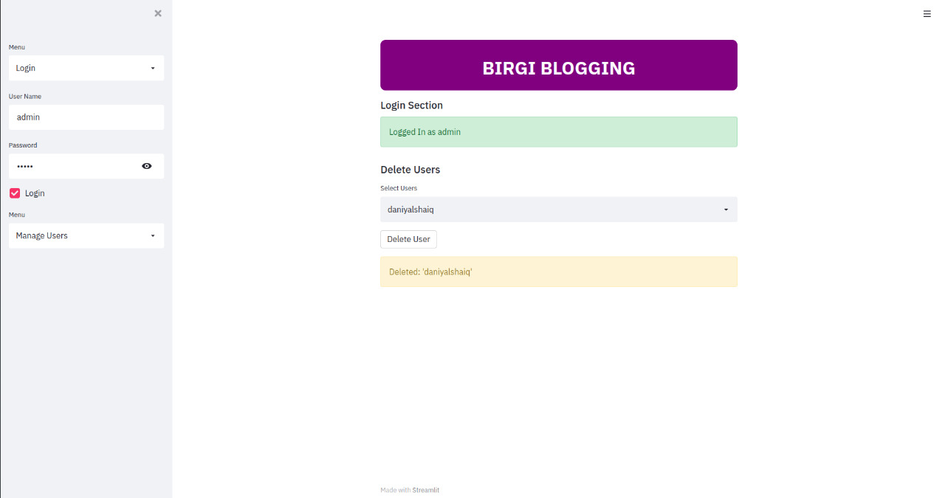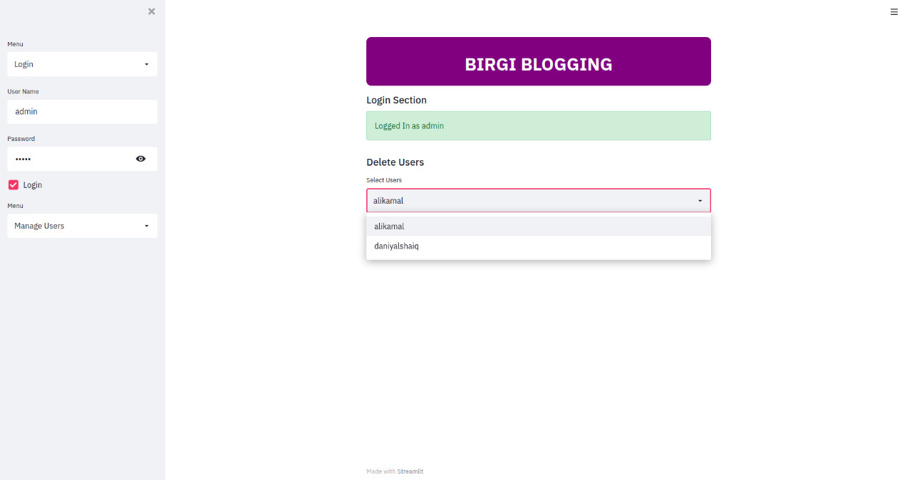**Admin blocking a user from making future posts:**
3. **Displaying article cards**

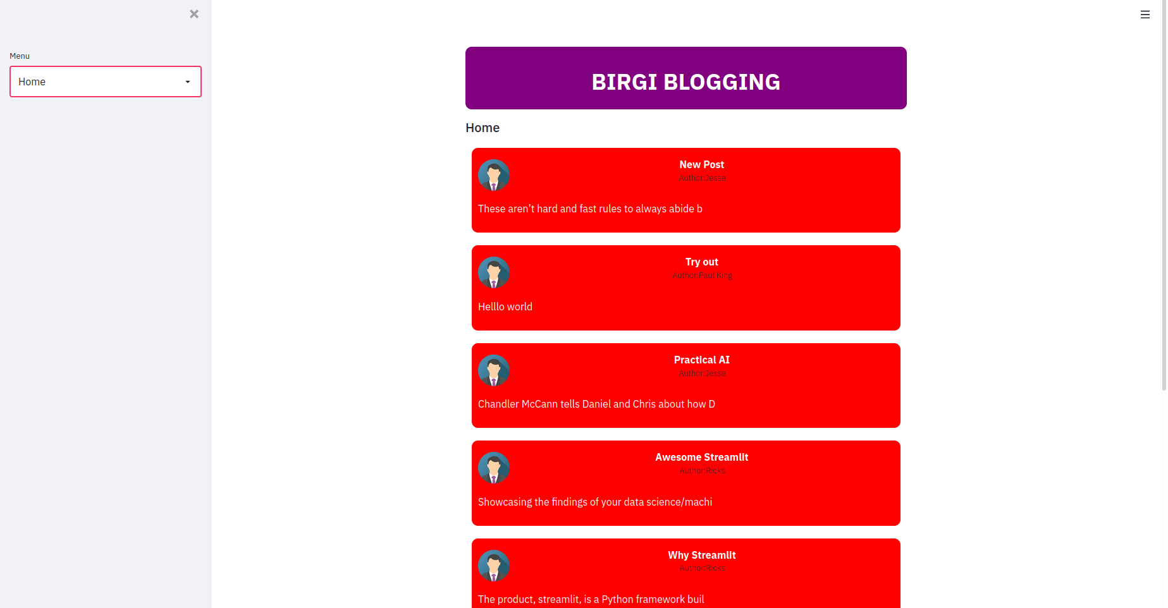

1. **Graph Analysis of article word count for each author:** 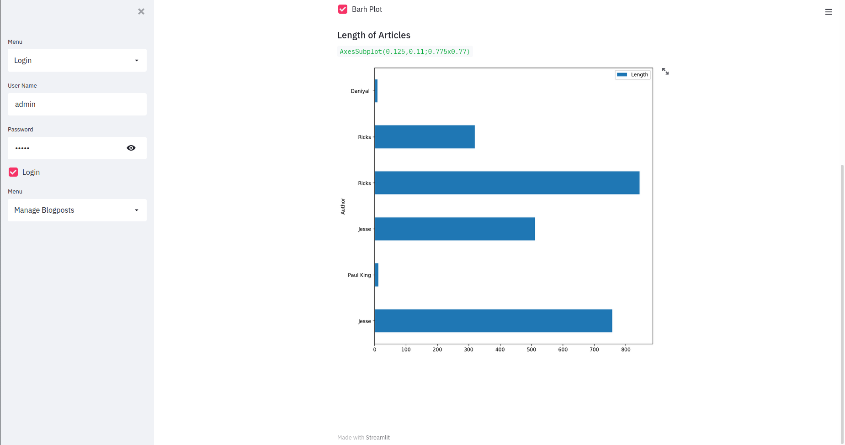
2. **Searching articles by their title:**

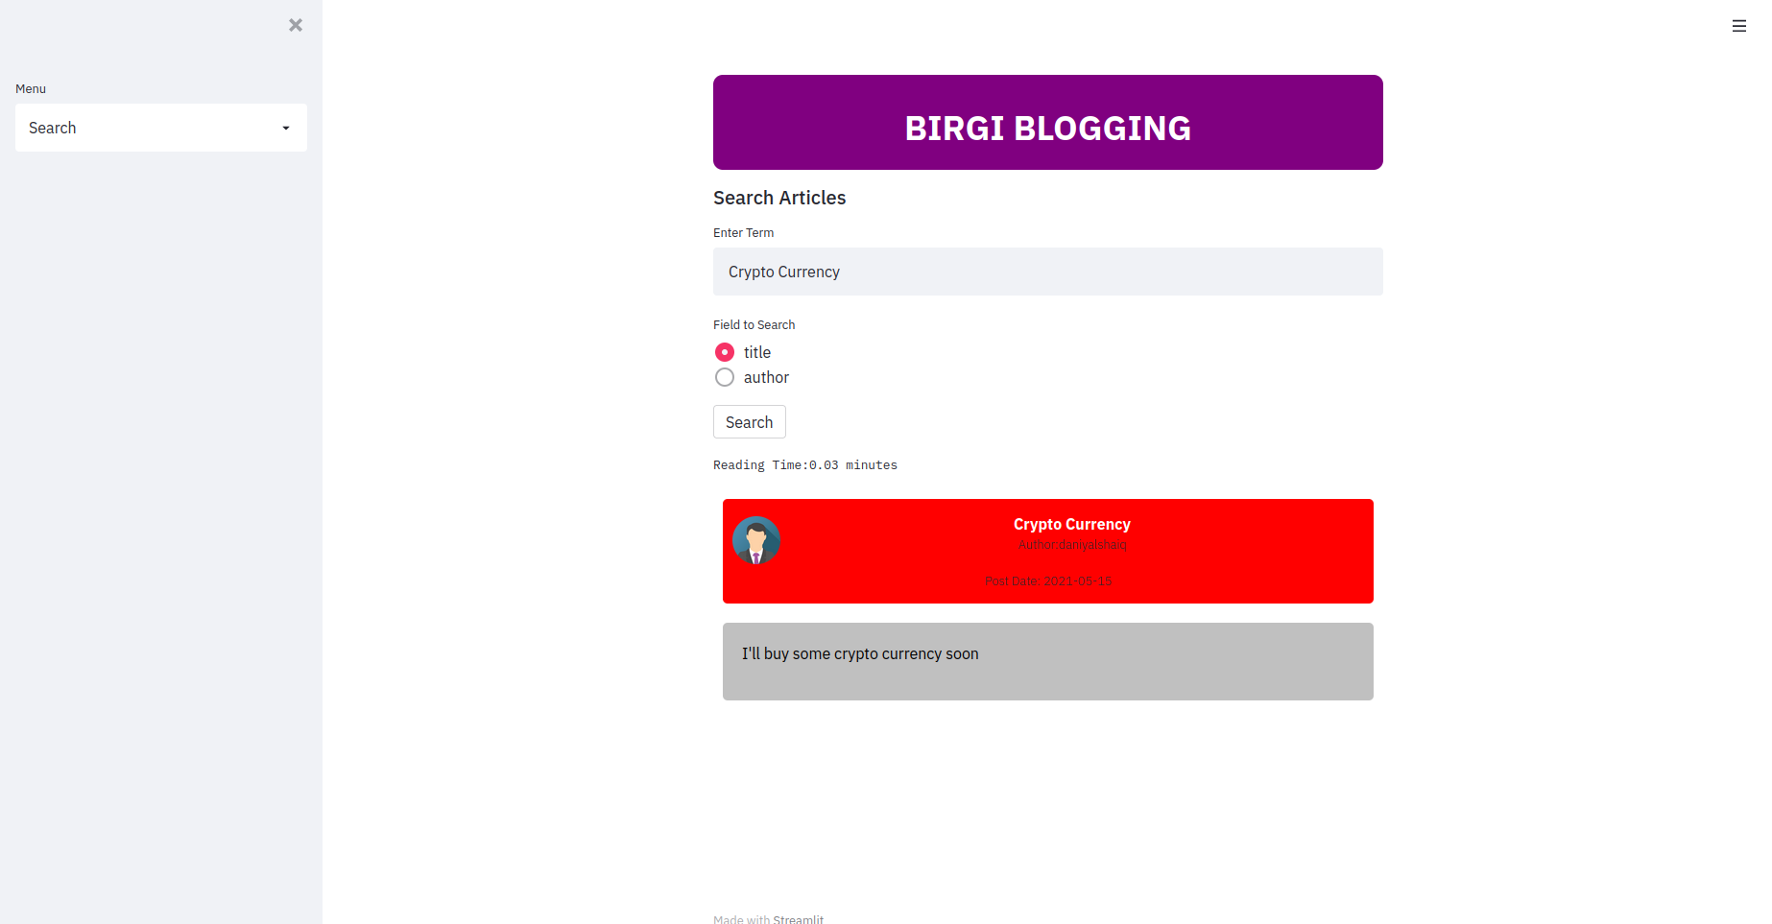

1. **Viewing all articles present on the website:**

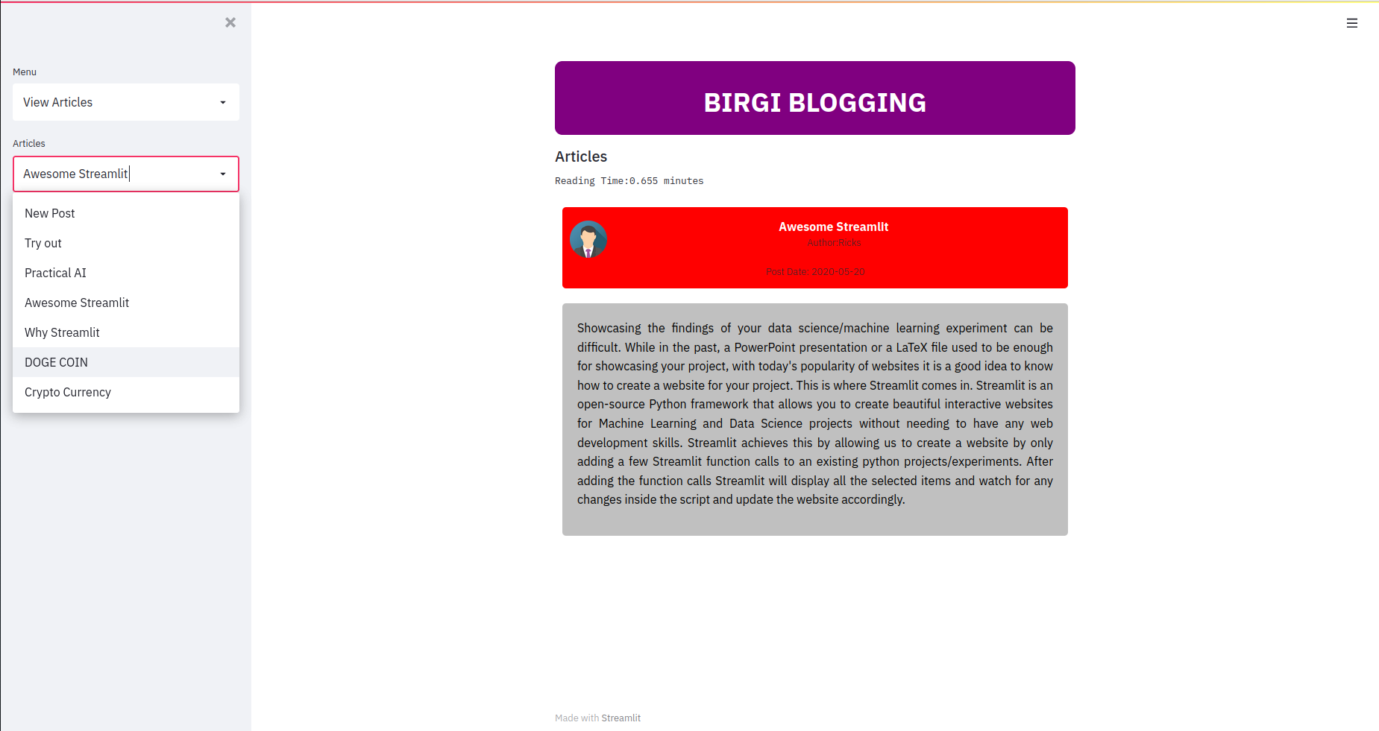

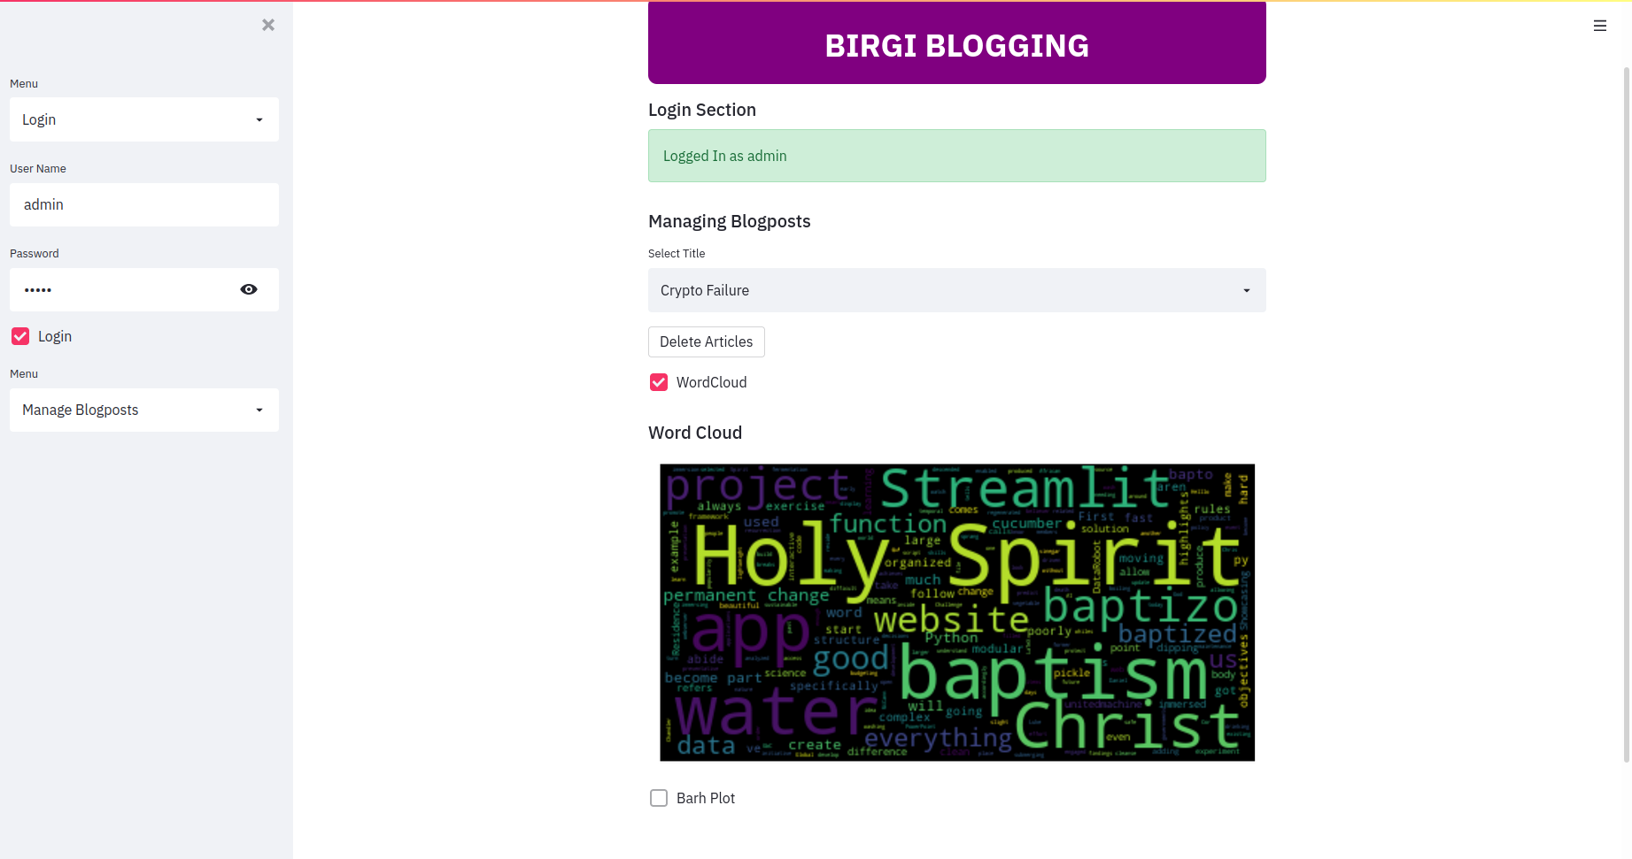

1. **Article word cloud:**
2. **User adding a rating:**

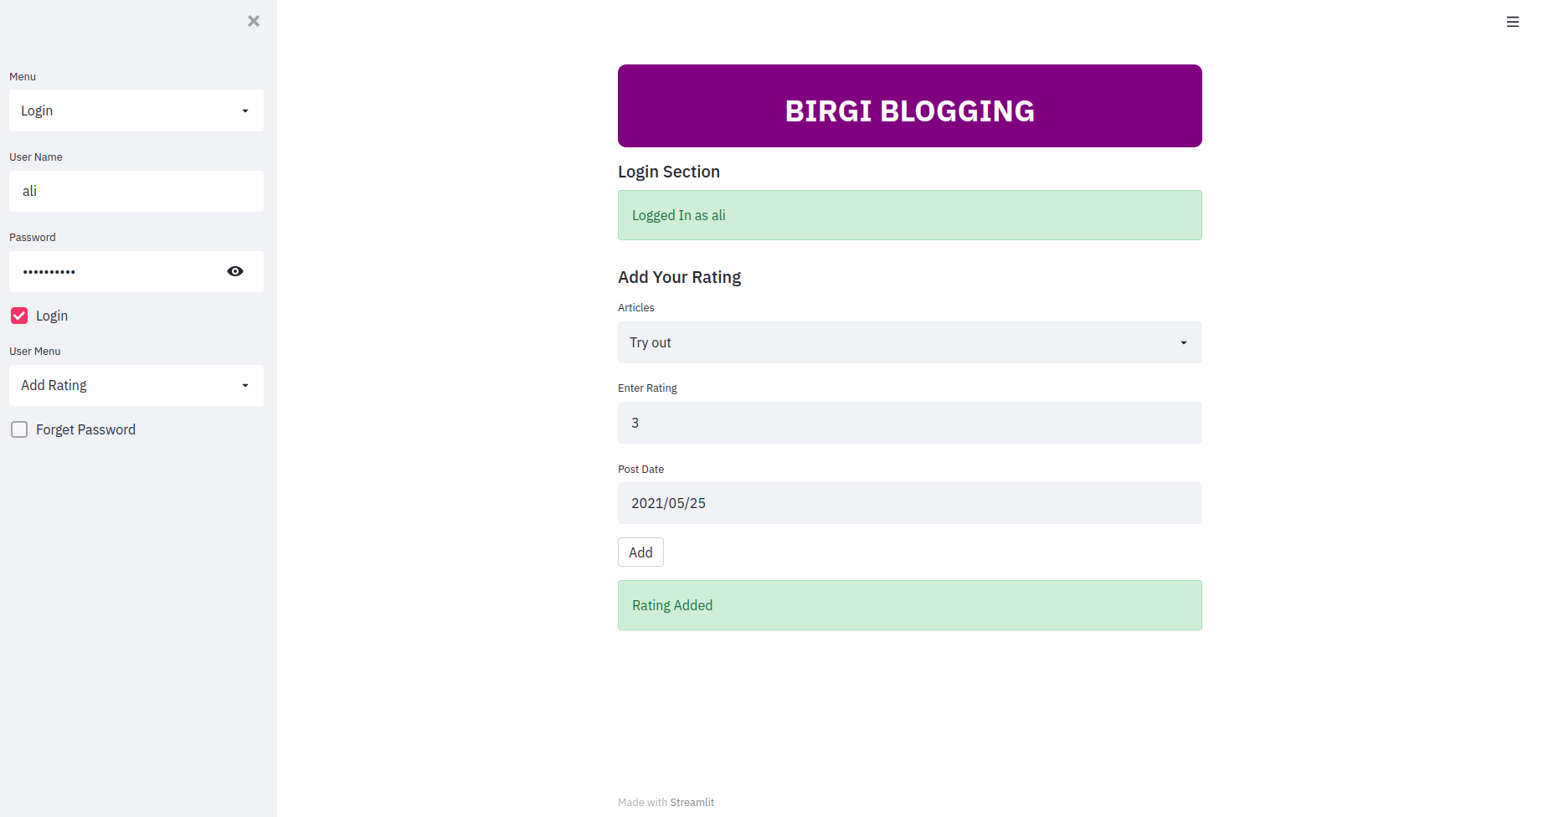

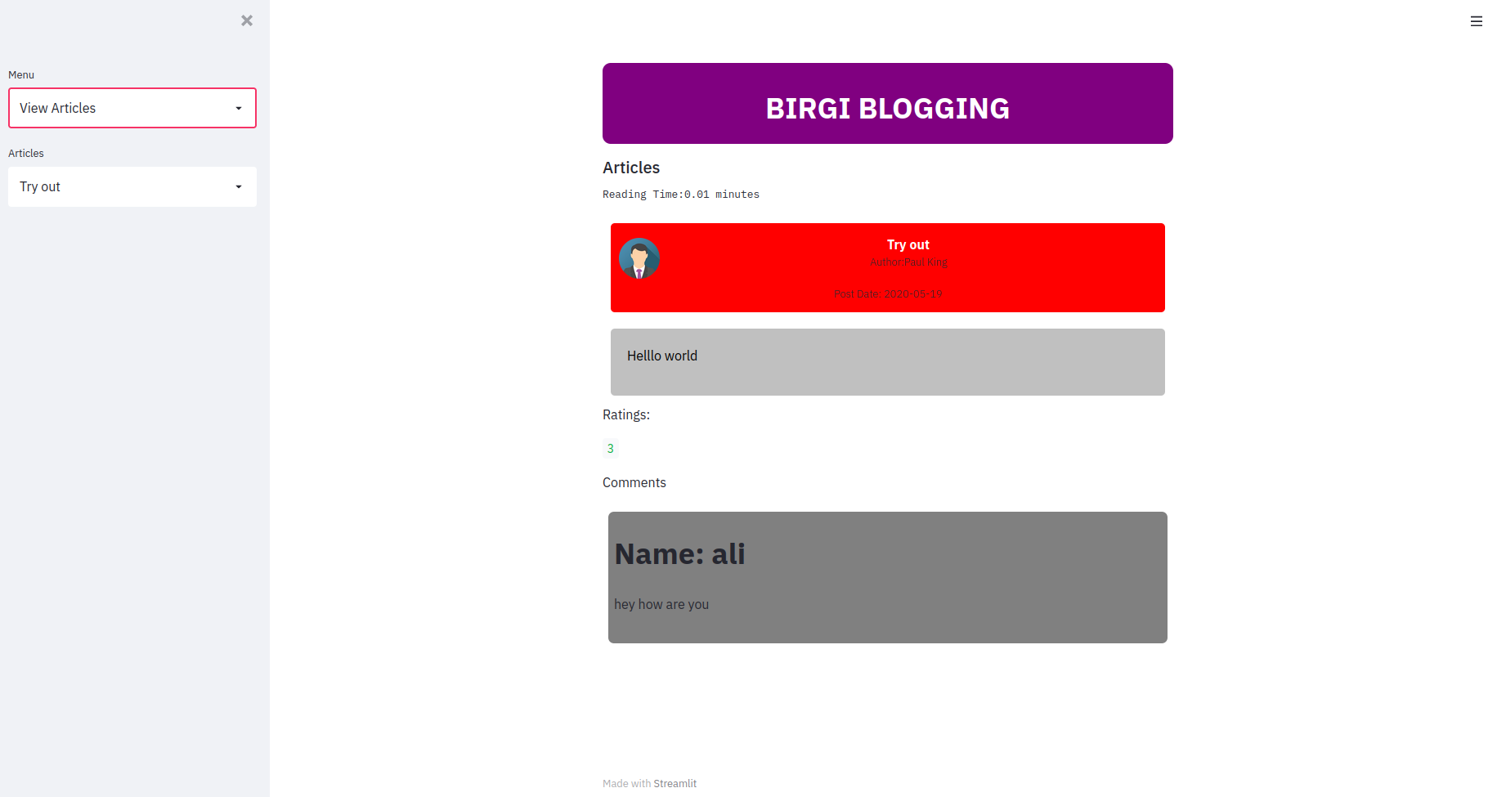

1. **User leaving a comment:**

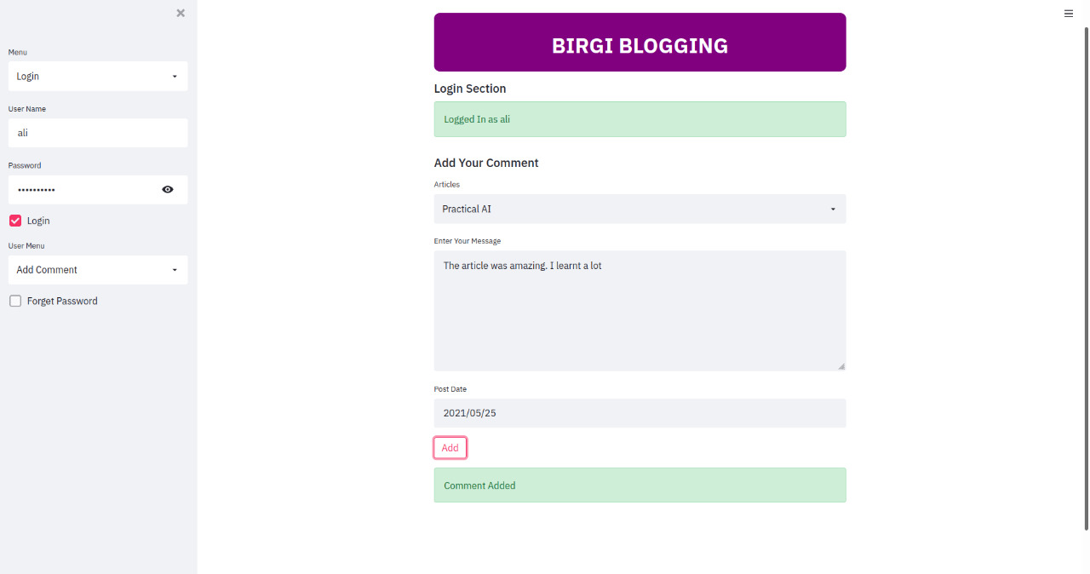

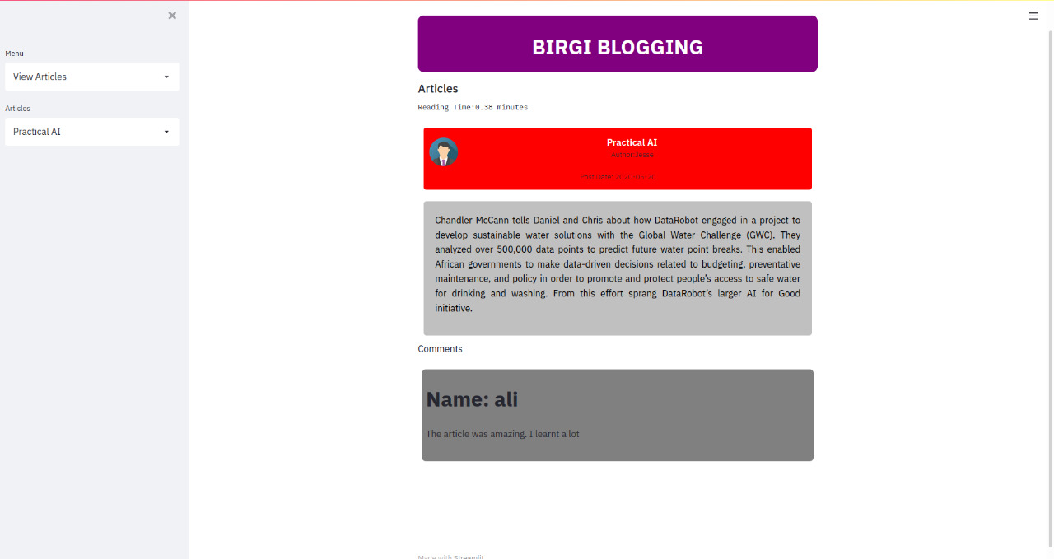

1. **Changing Password:**

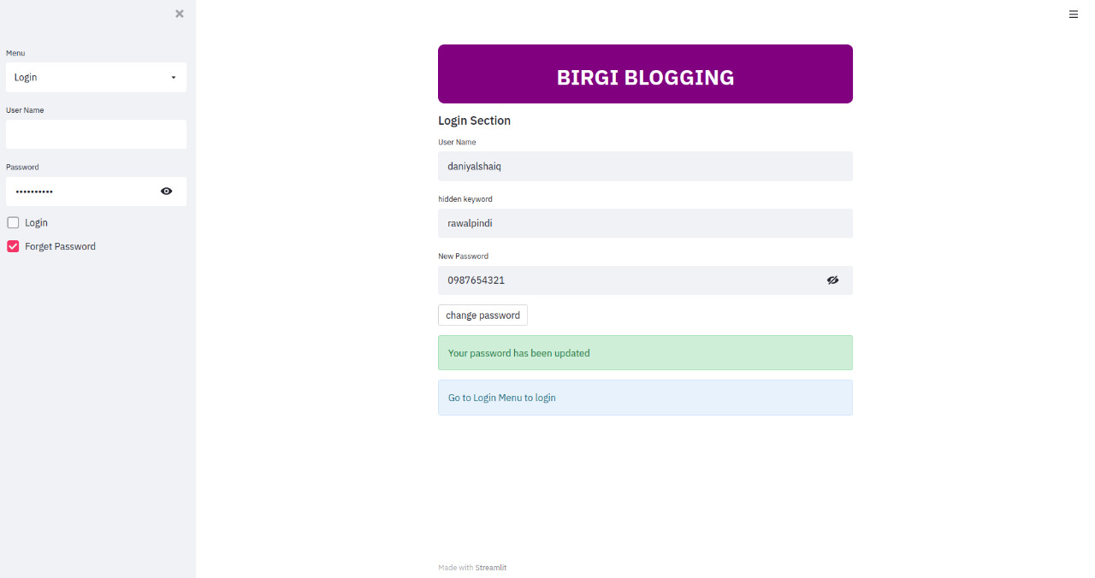

**Testing of UI Fields**

* **Adding post with empty title:**

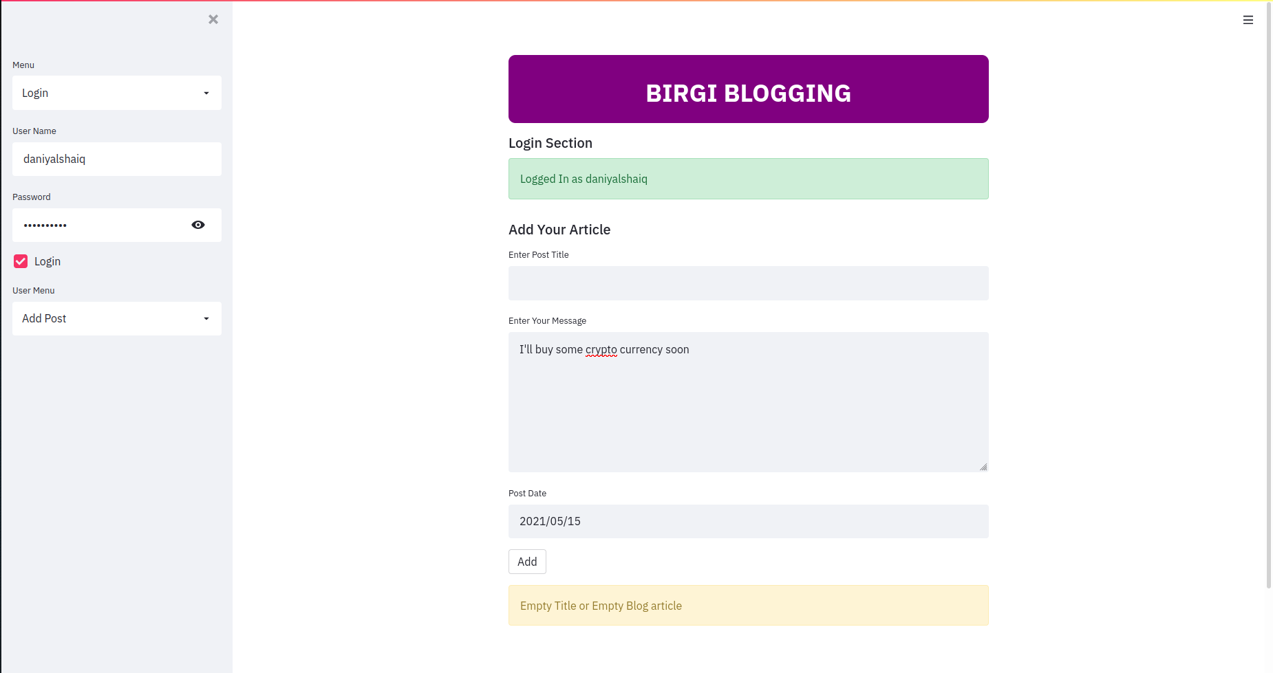

* **Incorrect Username/Password upon login:**

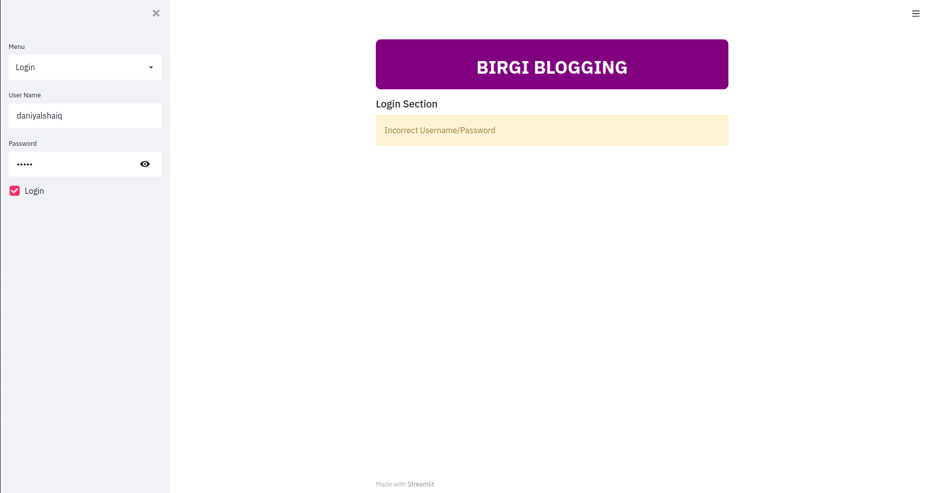

* **Password less than minimum length upon creating an account:**

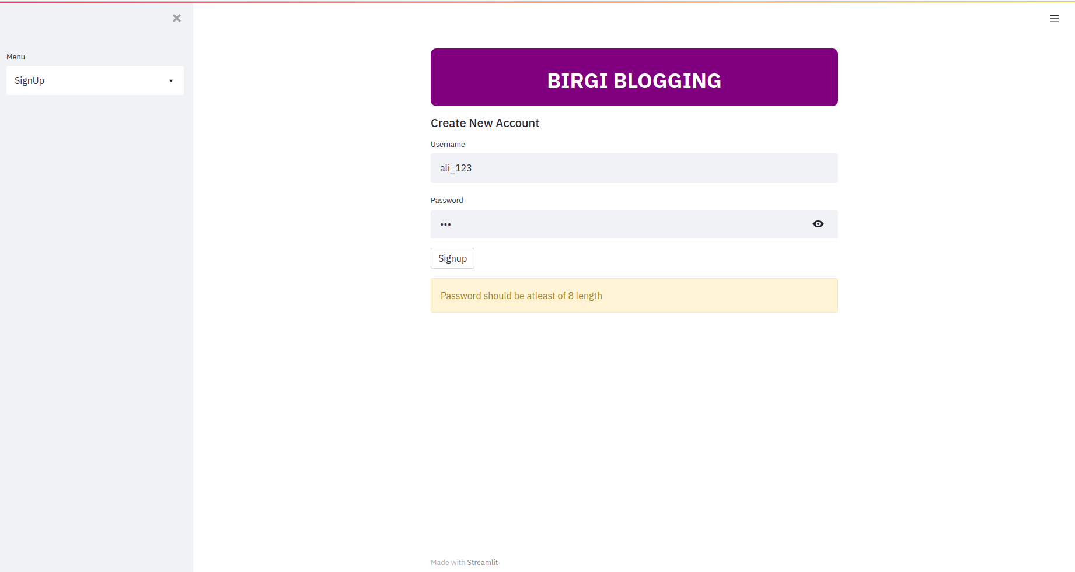

* **Leaving a rating that is out of bounds (not between 0 and 10):**

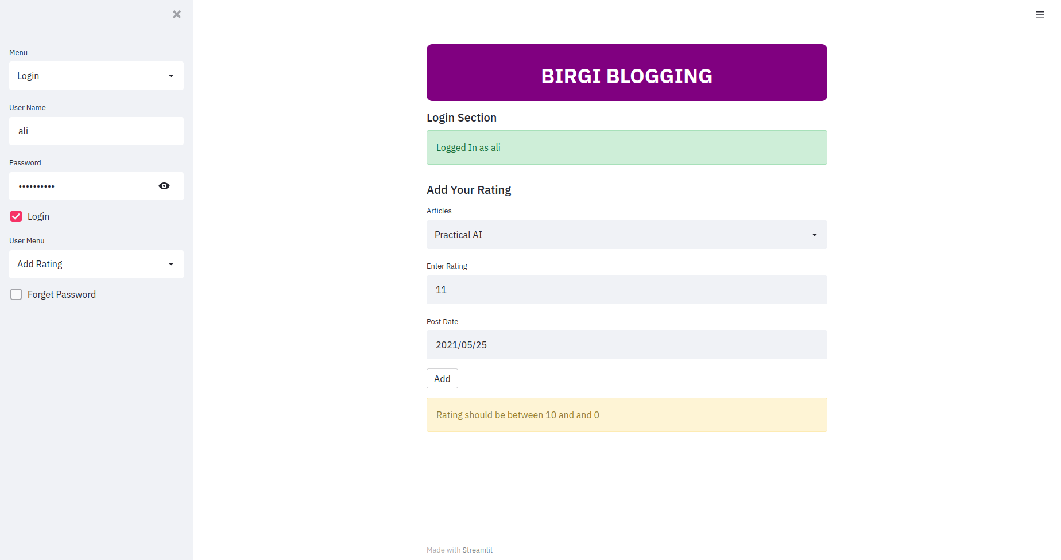

* **Incorrect Username entered upon password reset:**

